**Name: MATHAN RAJ T**

**Project Title: HOW TO ADD A GOOGLE ANALYTICS TO A WEBSITE**

**DEPARTMENT: COMPUTER SCIENCE AND ENGINEERING**

**COURSE DETAIL: DIGITAL MARKETING**

**COLLEGE: DHANALAKSHMI SRINIVASAN INSTITUTE OF TECHNOLOGY**

**NM ID: C1E61A1F6D2138798524D4CD543FFFE4**

**ZONE: 12**

**BIKERS CLUB**

**ABSTRACT:**

Bikers Club is a pioneering venture set to redefine the motorbike industry by offering an all-in-one solution for sales, rentals, and service. With a diverse inventory catering to various needs and preferences, our sales division ensures a seamless purchase experience.

Our rental service provides easy and accessible short-term motorbike solutions, while our proficient service team guarantees efficient maintenance and repair services.

By integrating technology, expertise, and customer focus, we aim to transform the motorbike experience and establish ourselves as the go-to destination for all things motorbike-related.

**Step 1: Google Analytics.com**

**Step 2: Account creation**

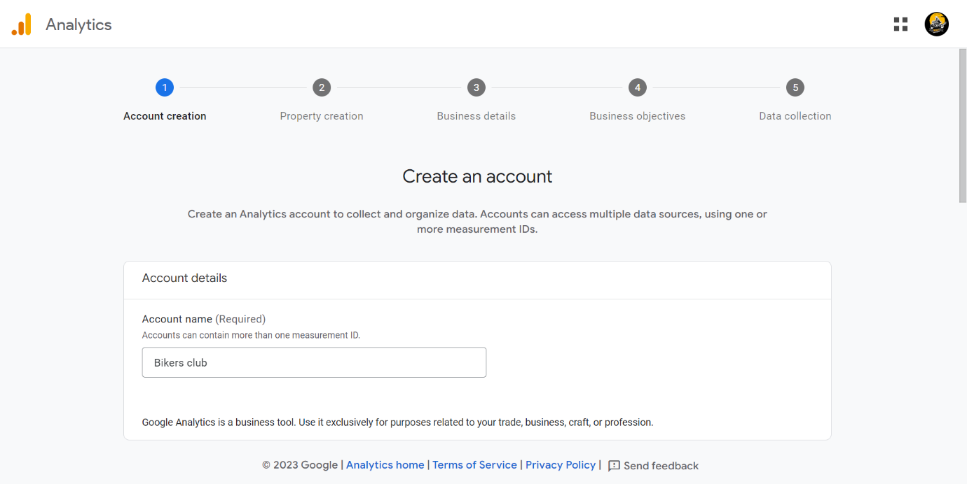

**Step 3: Property setup**

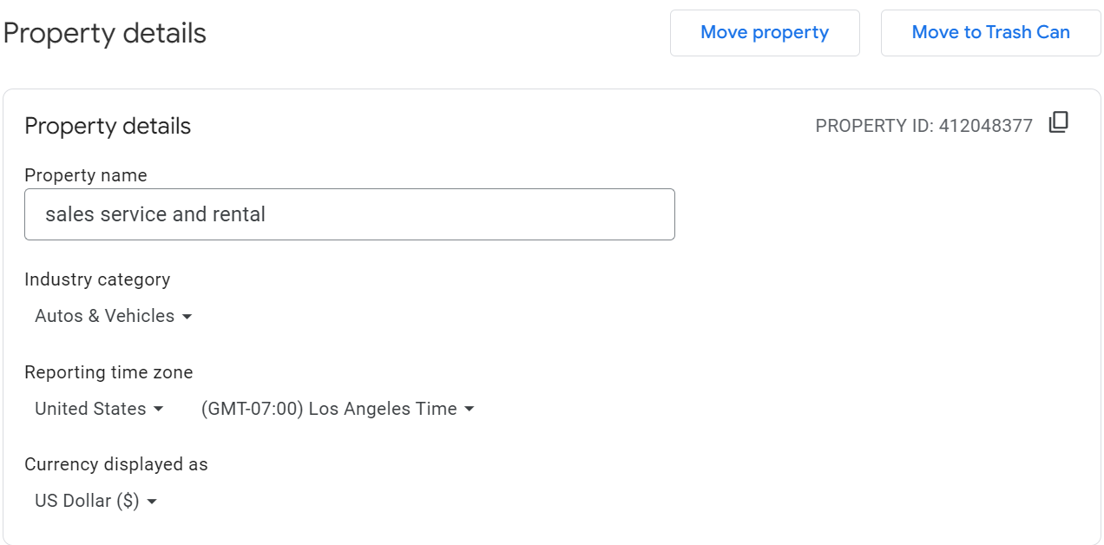

**Step 4: Add your website URL**

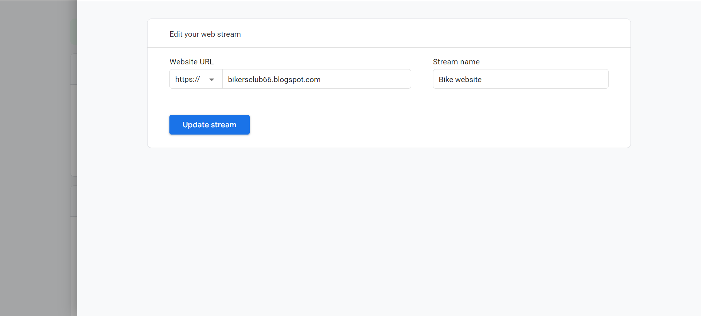

**Step 5: Web Stream Detail**

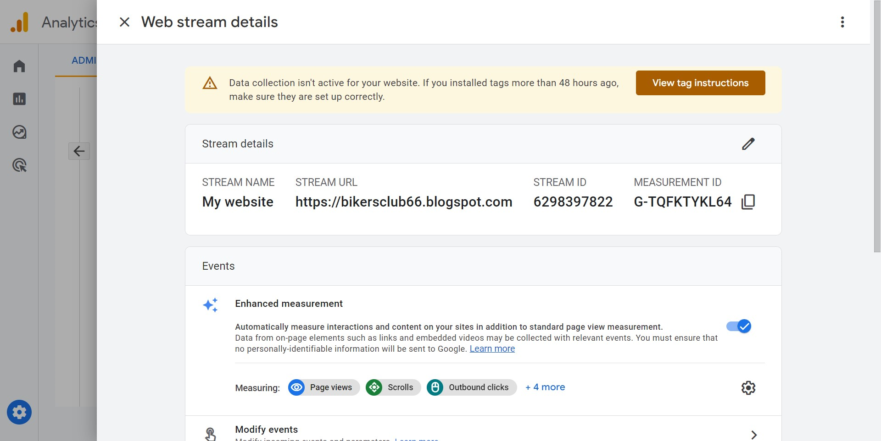

**Step 5: Add Google Tag**

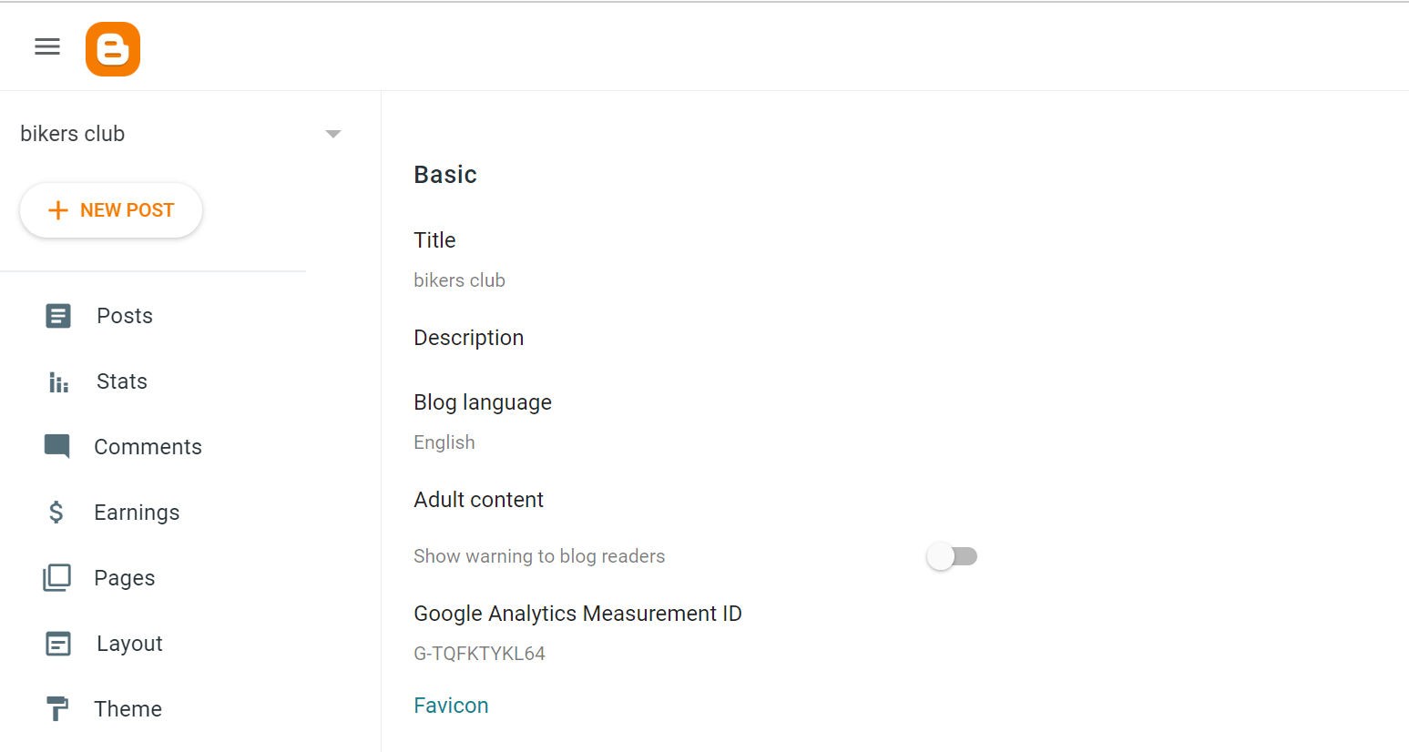

**Step 6: Final**

